Wind parks and feeding behavior of gulls

*the influence of wind parks on the feeding behavior of gulls in the North Sea*

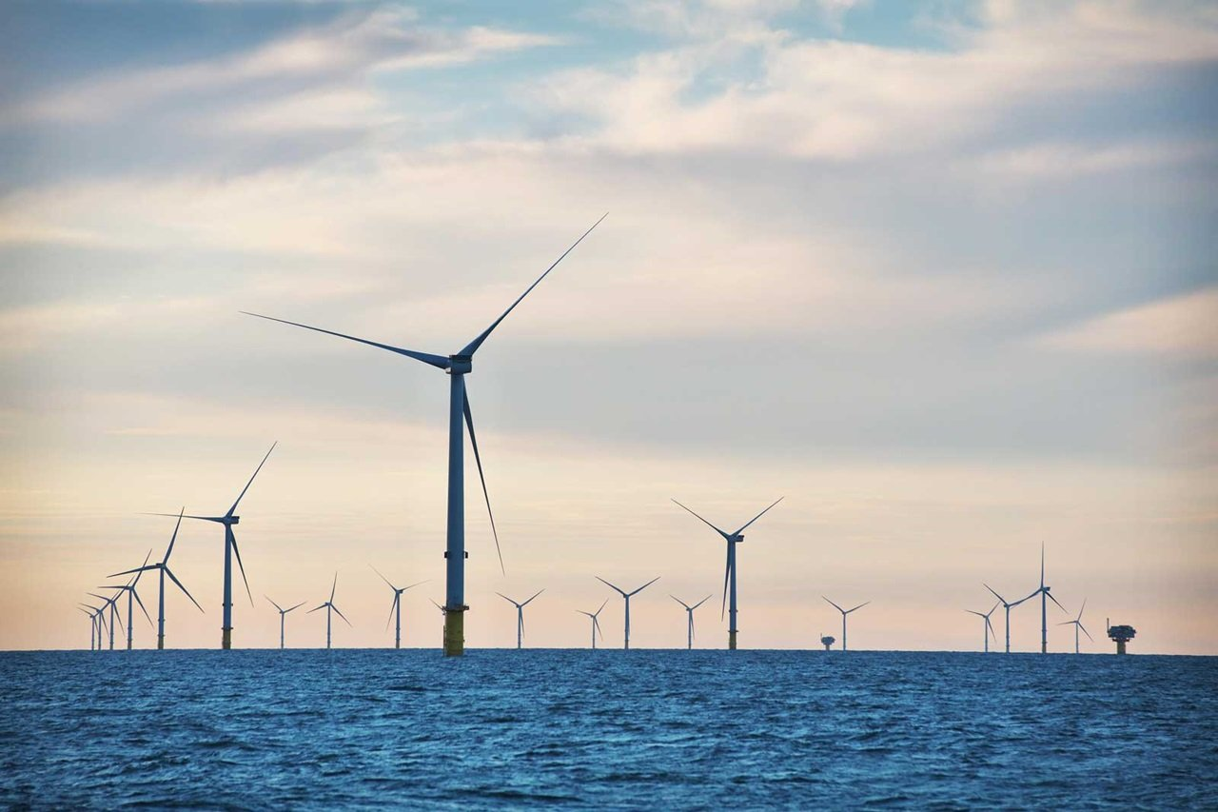

*Wind park near Ijmuiden, The Netherlands (Io, 2024).*

Author: Constantijn Hoogerwaard (12765295)

Words: … words

Date and place: 2025, Amsterdam

Supervisors:

Examiner: Dr Eldar Rakhimberdiev

Second reader: Prof dr. Kudy Shamoun

University of Amsterdam

Institution: Institute for Biodiversity and Ecosystems Dynamics (IBED)

# Acknowledgements

xx

# Abstract

xx

# Index

Introduction x

Methodology x

Results x

Discussion x

Conclusion x

Bibliography x

Appendix x

# Introduction

xx

# Methodology

xx

# Results

xx

# Discussion

Xx

# Conclusion

xx

# Bibliography

xx

# Appendix

Xx